WEST LONDON WASTE AUTHORITY
Report of the Projects Director and Strategic Development Lead | 23rd September 2022
Food recycling projects Update

SUMMARY
This report provides an update on the Authority’s Food Waste investment in Borough Business Cases, approved in September 2020.
RECOMMENDATION(S)
- The Authority is asked to approve an extension the time frame for project return evaluation from 3 to 5 years.
- The Authority is asked note the remining information within this report.
- Introduction - The West London Waste Food Waste investment was approved to set aside £3m of reserves to fund investment in the Borough food waste business cases to increase food waste collection only.
- Background - There are multiple factors that impact on the food waste system and therefore Officers have measured key metrics in the system as well as overall waste trends. The food waste service is predominantly a waste reduction measure as well as the benefits derived from diversion away from residual.
The food waste system is therefore a function of the following metrics:
- Separate food waste collected
- Proportion of food in the residual
- Residual waste volumes
- Capture rate
Each of these metrics have an impact on the value of a return on investment and therefore need to be considered together.
- Food projects updates
In 2020 the boroughs submitted project outlines setting out how the funding would be used and key results to monitor projects against. There have been external factors and internal changes in many boroughs which have resulted in some changes of project scope or timetable. This section outlines the status for each food recycling project up to the end of June 2022 and is based on information provided by the Borough’s delivery teams.

Approved Projects by Borough
Borough | Project
Brent | Provide 56,000 flats with equipment and consumables to increase the utilisation of the collection service .
Ealing | Introduce service to 20,000 flats that currently do not receive a food waste collection service.  Supply of new equipment and targeted communications to 25,000 homes in 11 current collection rounds to improve volumes collected i.e. efficiency.
Harrow | Introduce commercial collections (1500) and Flats Above Shops (800 FAS) service.
Hillingdon | Introduce separate kerbside food service to homes either with no service or currently receiving a mixed organic service.
Hounslow | Introduce service to 25,500 flats that currently do not receive a food waste collection service.  Supply of new equipment and targeted communications to 10,500 homes in 5 current collection rounds to improve volumes collected i.e. efficiency.
Richmond | Provide 17,000 flats with equipment and consumables to increase utilisation of the collection service  Introduce a commercial waste collection service to 540 new commercial customers

Brent
- LB Brent in conjunction with their contractor have surveyed most Communal collection blocks and re-instated food collection services where possible.
- LB Brent are currently recruiting a project team to deliver the project.
- The project aims to provide a new food recycling service to 56,000 properties in blocks of flats.
Ealing
- Ealing have added just over 9000 properties across 146 blocks of flats to the food recycling service.
- 3853 non-participating homes received targeted information about the services provided in August 2021 with follow-up leaflets at the beginning of January 2022.
- The next steps for the project are to identify further properties to be added to the collection rounds and to target additional properties at locations where the food recycling bins contain significant amounts of non-food contamination.

Harrow
- Harrow’s Project Manager began work in October 2021. Food recycling bins and housing units for flats have been procured.
- An assessment of the service provision at blocks of flats is underway and it’s anticipated that new properties will be added to the service during Q2 of 2022/23.
- Flats above shops service options are currently being investigated

Hillingdon
- A separate kerbside food service has been introduced to all homes that previously received a mixed organics service.
- Separated optimised food and green waste collection rounds were created by WLWA’s Project Team using specialist software. 5,016 new kerbside properties have been added to the service since May 2021.
- Over 4000t of food waste has been separately collected.
- Bin sensors have been installed into five schools to track usage of new food waste service following communications and engagement with the schools.
- A trial food recycling service has been introduced to 159 flats. The plan is to expand this service to as many flats as possible in Hillingdon Housing estates throughout 2022/23
- Hillingdon are in the process of recruiting two Recycling Officers in part to deliver on a target to reduce food waste by 10%. This will also involve a targeted campaign to increase the number of kerbside subscribers to the collection service.
Hounslow
- 15,000 flats have been added to the food recycling service. The collection service is operating using smart data collected from bin sensors. 455 additional tonnes of food waste collected since start of project. This represents a disposal saving of c.£46k to Hounslow Council and 5,628kg CO²e of emissions to date through diversion from the residual waste stream.
- The bin housings which were ordered early in the project timeline have been delayed due to a national shortage.
- The 2 vehicles to be used for the bin swapping service have been ordered and hired vehicles are being used until they arrive. The bin swapping service has been in operation since April 2022.
- The monitoring of this service and use of bin sensors to detect fill rates means there is a clear understanding in the amount of food generated across the total number of properties served. This data shows that 0.50kg/hh/wk has been collected.
- A targeted communication campaign was carried out in the Brentford Dock estate to increase the amount of food collected to 1kg/hh/wk, the impact was monitored by bin sensors.
- Limited participation monitoring targeted 440 non-participating kerbside properties in September 2021. This approach was also tried in three further wards in February 2022. Non-participating kerbside properties targeted with leaflet including QR code to permit recipient to request caddy. As no requests were received this approach is currently being re-evaluated.

Richmond
- The Project Assistant employed to work on this project has completed bin store assessments of 1,150 blocks (83% of all blocks) with 674 blocks deemed feasible for food waste recycling. Where the Management Agent is not known for the block, letters have been sent to residents to enquire. 48 Management Agents have been identified using this method. Richmond have been given permission by managing agents to install bins at 180 blocks serving 3.5k flats.
- Bin housing have been ordered but due to national demand their arrival has been delayed. A service leaflet, bin and bin housing stickers have been designed and approved.
- Richmond are currently waiting for confirmation of a start date from their contractor, Serco, for delivery of the service to commence.
- The provision of a commercial food recycling collection service is currently on hold.

West London Waste Authority
- Procurement support for containers, bin housings and caddies.
- Installing and operating the bin wash system at Transport Avenue
- Providing fleet routing and efficiency services for integration of new properties on rounds and new services.
- Trialling Smart Cities technologies to measure fill and collection rates to generate smart routing for rounds with bin sensors
- Communications support and resources for food waste services
- Round performance mapping to establish high and low yield areas
- New transfer operation for food waste at Victoria Road transfer station.

- Tonnage of food collected through borough food recycling services
Food waste trend from year-on-year change analysis
The total tonnage of food separately collected for recycling has steadily increased year on year as shown on the graph below, until the Q1 2022. The inclusion of the Hillingdon separately collected material has provided a significant proportion of this growth.

  - Figure 1 – Food Waste tonnes with trendline
Change in food collection since 2020
The following graphs show how the collected weight of food has changed since a pre-pandemic baseline year, the chosen baseline is the average of 2018-19 and 2019-20 (having an average of 2 years reduces the effects of one-off events). The total to date tonnage increase since the baseline years is c.7400tonnes.
Note – Hillingdon data is not included in these graphs because a separate food recycling collection was only introduced in 2021 therefore no baseline data exists.
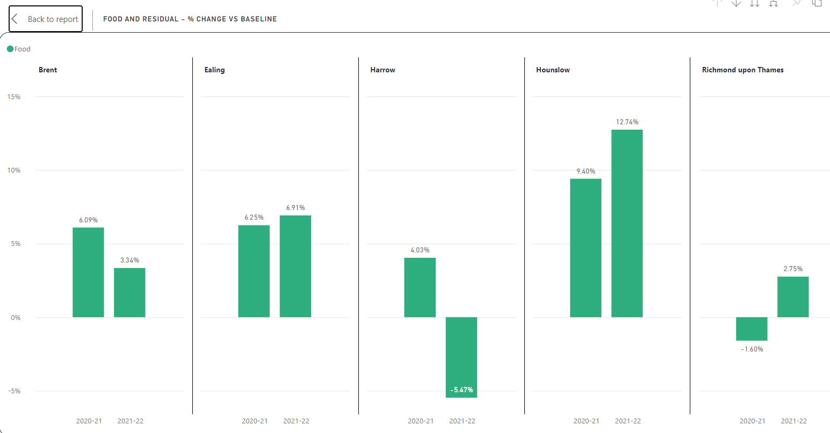
  - Figure 2 – Borough food volume vs baseline
The West London food waste service has seen a reduction in all waste streams including food since the end of the pandemic.
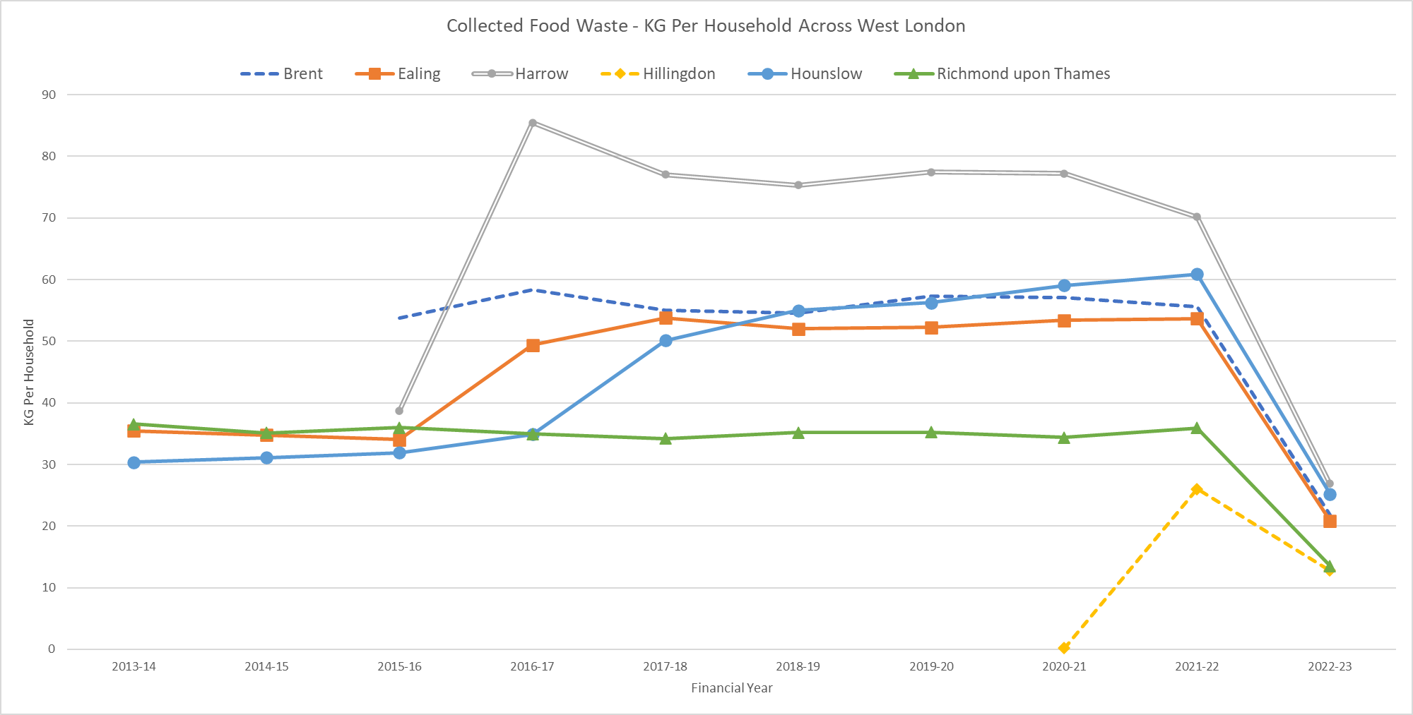
The figure above shows the evolution of the food waste services by kg/household. This gives an indication of the relative positions of the services and capture. Please note the current year 2022/23 is only part year data.
- Food waste in residual
The absolute volume of food waste captured only covers a proportion of the full food waste system. Food waste generated in households across west London predominantly flows through two routes. The food waste service covered above and unfortunately through the residual waste where households are not participating in food service provided.

WLWA officers have contracted a waste composition survey to be completed by the middle of October 2022 which will also be used to inform this work. The previous waste composition work has indicated the proportion of food waste in the residual stream has dropped from c.41% in 2019/20 to c.31% in 2021/22. This is the equivalent reduction of c.30,000kpta of food waste.
Residual had been increasing throughout the pandemic and as the stream containing greatest volume of food waste this growth needs to be factored into the separate food collection increases. During this time residual waste volumes have been c.7% higher than the baseline years versus the 11% increase in food collected separately. If this figure is used to create a weighted mean food collection tonnage the effective uplift is 4% or 1186 tonnes.
This supports the increase in separate collection but reduces the benefit. To ascertain the wider impact of this changing baseline the capture rate of food service needs to be calculated.
- Capture of food
Using the tonnage data from food recycling services and the waste composition analysis for each of the last 3 years the capture rate for food being thrown away (whether placed in rubbish bins or in the food recycling services) can be measured as a snapshot in time. The graph below shows the total amount of food being thrown away is reducing gradually year on year and the proportion of it being placed in the food recycling service is increasing.

  - Figure 3 – WLWA capture rate and waste reduction
This supports the increase in participation through the expansion of the services by Boroughs (increasing capture rate) and the waste reduction theory for the service (total kg/household/week reducing through time).
- Financial Implications –
As detailed above the measures for the evaluation of the services is difficult to measure as a single function. The measures above independently would deliver savings on the WLWA food projects investment to date as follows:
Measurement | Saving
Food waste collected | c.£750,000
Food waste reduction | c.£3,100,000
Residual weighted food waste collected | c.£120,000

WLWA officers will continue to monitor and measure the impacts of the investment and the benefits delivered through the projects with updates annually to the Authority on progress.
Approval – Projects have commenced within the delivery period, however in order to capture the full benefit of the investment and given the impacts of the pandemic on project commencement WLWA officers request that the evaluation period for the returns be extended to 5 years.
- Staffing Implications – None
- Health and Safety Implications – None
- Legal Implications – The Environment Act 2021 includes a requirement for every household to receive a separate food waste collection service. The projects identified are leading best practice for flats and flats above shops food waste collections services.
- Joint Waste Management Strategy
The projects mentioned in this report Deliver increased recycling and the cost savings needed to reinvest in reducing our carbon emissions.
Contact Officers | Peter Tilston, Projects Director 01895 545510  petertilston@westlondonwaste.gov.uk  Sarah Ellis, Strategic Development Lead  sarahellis@westlondonwaste.gov.uk

